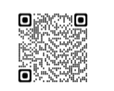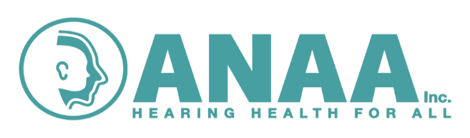
’Ear ‘Tis
2025 Volume 36 Edition 3
Newsletter for Audiometry Nurses
www.anaa.asn.au
Audiometry Nurses Association of Australia Inc.
‘The professional association for Audiometry Nurses’
Welcome to this issue of the ANAA Inc newsletter

Presidents Report September 2025
Dear Members,
We hope you've all come through the winter in good health. It’s been another busy year, and Gisella and the team are currently finalising plans for this year’s conference. Once again, it’s shaping up to be an engaging and enjoyable event. If anyone is interested in hosting next year’s conference, please get in touch with the committee—we're here to support you every step of the way.
Important Dates:
- Conference Registrations Close: 21st September
We are required to provide final numbers to the venue three weeks in advance, so please don’t delay—get your registrations in as soon as possible.
- AGM Notice:
Our Annual General Meeting (AGM) will be held during the conference. AGM details and forms will be sent out in a separate email next week.
Membership Update:
A big thank you to all our dedicated members who have already renewed their membership—we truly appreciate and value your ongoing support. And a huge welcome to our students that have taken up associate membership this year.
If you’re unsure whether your membership is up to date, please contact our Membership Secretary, Helen Gee. Those who have renewed will have received a receipt of payment from Helen. To those who have informed us of their resignation—thank you. We sincerely wish you all the best in your future endeavours.
Page 1
Ministry of Health Collaboration:
We’ve been in ongoing correspondence with the Ministry of Health regarding the revision of the Audiometry Report and History forms. We're pleased to report that progress is finally being made, and we’re hopeful that the updated forms will be finalised by the end of the year.
Fact Sheet Updates:
Five of our fact sheets have now been updated following a process involving health literacy review, community consultation, and graphic design through NNSWLHD.Four are already available on our website: www.anaa.asn.au. ( Ed note: and attached to this Email) We're working to reduce the file size of the fifth one so it can be uploaded. Two additional fact sheets are still due for updates, and a couple more are scheduled to be written—these will be part of our 2026 projects.
Conference Dinner Theme:
This year’s dinner theme is Ladies Day at the Races—so dust off your fascinators and get ready to have some fun!
Special Announcement – Life Membership:
We’re thrilled to share some exciting news—our former president and long-standing audiometry nurse colleague, Tracy Hawes, has been awarded Life Membership.Tracy has graciously accepted this honour. She has also recently resigned from her permanent Audiometry role in Parramatta & Mt Druitt. We thank her for her incredible contributions and wish her all the very best for the future.
Warm regards,
Kate Norton President ANAA Inc.

Contents in this issue
Presidents Report | 1-2
Contents/ Letters | 2
ANAA information/ Scholarships | 3
New projects | 4
What’s New | 5
WHO information | 6
News | 7
Committee Contacts | 8
Letters to the Editor
This column provides a forum for discussion and an exchange of ideas. The letters page gives members the opportunity to comment on newspaper and journal articles. You are invited to submit clinical case studies, questions or queries for discussion. Send any comments or concerns that you would like to go to the committee to this column. Have a go and tell us your news! – Editor
Page 2
Membership/ Scholarships
Membership for 2025
Membership of our association was due on the 1st July. Please renew your membership as soon as possible to remain current. Membership forms are available on the website or were Emailed out in July. If you haven’t renewed by end of September you will be sadly removed from the membership list and need to reapply. If you are retiring then please let our membership officer know. Helen.Gee@health.nsw.gov.au
Link to membership:
Audiometry-Nurses-Association-of-Australia-Inc.pdf
We welcome all new members to our friendly group.
Resignations:
Sadly, Alena Ward has resigned from the association due to illness. She sends her best wishes and thanks to all she has worked with. Alena trained with Dr Rue Wright at Sydney TAFE in 1988 and recently practiced at Goulburn. Our thoughts are with Alena and her family.
Education Fund
A reminder that the ANAA has an education fund to assist with costs of education to our members. We have provided scholarships for the audiometry nursing course. The application is attached to this Email or available on the ANAA website.

Lions Nurses’ Scholarship
The Lions Scholarship Application Process is now fully online! Applications are only accepted through the online application process. Lions Nurses Scholarships open for application on 1 August and close on 31 October each year*. These are available to any eligible registered nurse or enrolled nurse. Applications are not accepted for consideration outside this period. The mission of the Lions NSW/ACT Nurses Scholarship Foundation is to provide the opportunity for nurses to continue their professional development.
Lions Nurses’ Scholarship NSWNMA - The New South Wales Nurses and Midwives’ Association
ACN Scholarships for professional development and Leadership
Scholarships – Australian College of Nursing
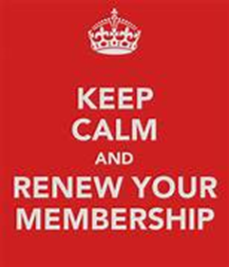
Page 3

Project tunes into ear health in remote NT communities
( from Rural Health Pro 14th August 2025 written by Nathalie Levick - sent in by Dee Parker)
NT Hearing Services has developed a cutting-edge tool that combines AI-powered geospatial mapping with analytics to track the prevalence of ear conditions and hearing loss across 93 communities and outstations in the Northern Territory.
Northern Territory Minister for Health Steve Edgington said the ground-breaking project, which won a prestigious award at the international AI for Good Global Summit 2025 in Geneva, will play a significant role in improving ear and hearing health outcomes, especially for vulnerable Territorians. "Aboriginal children have the highest rate of middle-ear infections in the world," he said. "If left untreated, this can cause hearing loss and affect speech, language development and learning, as well as resulting in long-term damage to ears.” "This standout innovative tool, developed by our Territory health practitioners, will be made available to remote communities across the Territory to track changes in ear and hearing health.” The project, called Geospatial Mapping of Otitis Media and Social Determinants in Remote Northern Territory Communities, was selected as one of 10 winners from a pool of 234 submissions across 32 countries, at the annual AI for Good Global Summit. "We are proud to be part of a key project that informs our services and commitment of care to Territorians," NT Hearing Services Director, Prasha Sooful said. The algorithm in the AI map is based on NT Health and ABS data and highlights how they can be used by different agencies for various purposes. NT Hearing Services will now finalise the data and run the AI algorithms for predictive analysis, with the map expected to be complete by 2026. The map can be broadened beyond health conditions to look at schools, roads, infrastructure and housing, and gives context to the remoteness of communities. It can also be shared with other states and territories as an example of using data in a meaningful way for a range of health conditions.



Page 4

As seen in Aussie Deaf Kids newsletter
Deaf Metal jewellery to cover a cochlear implant and secure it with a safety chain. Have a look at the range.
www.deafmetal.store/category/22/cochlear-implant-coil-hats
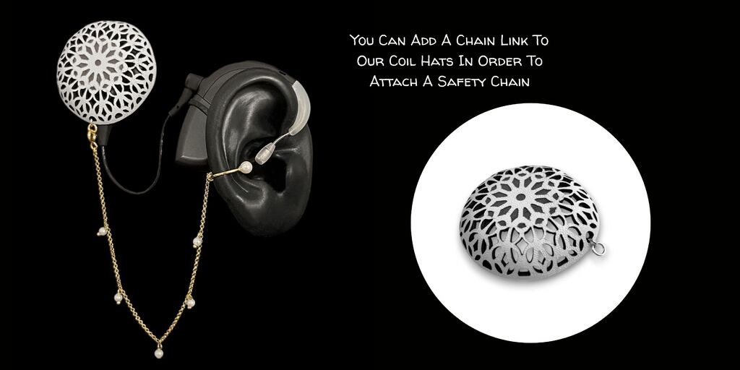
Research
A brief search of latest literature on hearing loss showed the following articles which may be of interest to you.:
Cost-Effectiveness of Screening Preschool Children for Hearing Loss in Australia - OvidDS
https://hearingpractitionernews.com.au/new-hearing-australia-data-shows-35-of-indigenous-kids-have-fluctuating-ear-disease/
https://pmc.ncbi.nlm.nih.gov/articles/PMC6197960/ This article is on NIHL in women with type O blood group. Only a small sample size but interesting reading. ( Thanks to Dee Parker for sending it through)


Page 5

Some information from the WHO Ear and Hearing Care Program \

On vision and hearing screening
Page 6
WHO has some recordings on their website around hearing and vision screening and the following resources:
- Vision and hearing screening for school-age children: implementation handbook
- Vision and eye screening implementation handbook
- Hearing screening considerations for implementation
- The TAP Vision and hearing screening for school-age children course
We hope these materials will support your efforts to design and strengthen school vision and hearing screening programmes in your context. If you would like additional information, please do not hesitate to contact us at whf@who.int or vision@who.int.
Kind regards, WHO Ear and Hearing Care Programme
Copyright © 2025 World Health Organization (WHO), All rights reserved.




Deafness Forum Australia has a new Hearing Health Resource Hub
It’s located on the Resources section of the Deafness Forum website. You’ll find fact sheets, practical tools, webinars, research, and more — all created to support
lifelong hearing health and make information easy.
Whether you’re a community member, healthcare practitioner or worker, other community support provider, educator, policymaker, or simply interested in hearing health, there’s something here for you.
https://www.deafnessforum.org.au/
( taken from One in Six- Deafness Forum newsletter)

AUDIOLOGY EQUIPMENT CALIBRATION BY NATUS SENSORY
Bring along your equipment to be calibrated during the Audiometry Nurses Assoc. Conference
Our qualified Engineer will be onsite to calibrate your equipment for $300 per device on the 16th and 17th October 2025
To make a booking email: service.anz@natus.co or phone: 1800 290 772
natus.sensory

Don’t forget the conference !
 Page 7

ANAA Committee Contacts
President
Kate Norton Northern NSW LHD
Grafton Community Health Centre Arthur Street, GRAFTON, NSW, 2460
Phone: 02 6641 8702 Fax: 02 6641 8703 kate.norton@health.nsw.gov.au
Vice President
Belinda Wilson
Forbes Community Health, 4-6 Elgin St, FORBES. Tel (02) 6850 7300- Thurs/ Fri
Grenfell Community Health, 80 Cowra Road, GRENFELL Tel (02) 6349 1750- Tues/ Wed
Belinda.wilson@health.nsw.gov.au
Secretary
Kirsten Biddle Hunter New England LHD
PO Box 701 Inverell NSW
Phone: 02 67219600 kirsten.biddle@health.nsw.gov.au
Treasurer
Sarah Austin Western NSW LHD
Coolah.P: 02 6377 9166 Mobile: 0431534337
sarah.kemp1@health.nsw.gov.au
Committee Member/ Membership Secretary
Helen Gee Mid North Coast LHD
Port Macquarie Community Health, 19-31 Morton Street, Port Macquarie
Tel (02) 6589 2100 | Mob 0427 517 314 | helen.gee@health.nsw.gov.au
Committee Member/ Social Media
Gisella Laughton Nepean Blue Mountains NSW LHD
Springwood, Lithgow & Penrith Community Health Centres Tel 02 4751 0100 gisella.laughton@health.nsw.gov.au
Committee Member/ Editor ‘Ear ‘Tis
Lee Lewis Western NSW LHD
Bathurst Community Health Centre Howick St Bathurst 2795
Blayney Community Health 3 Osman Street, Blayney 2799. Phone: 02 63689314
Lee.Lewis@health.nsw.gov.au
Page 8

