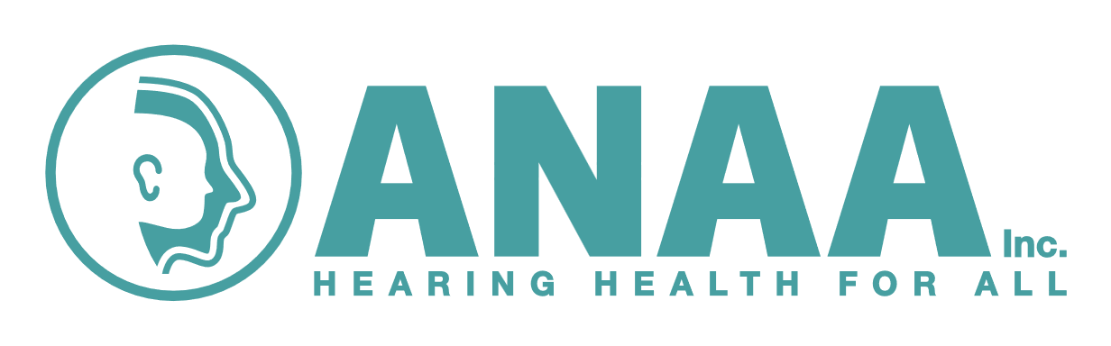

**Clinical Advisors in Audiometry Nursing 2025**

A Teams workshop will be provided to those who wish to maintain or become an accredited Clinical Advisor for Audiometry Nursing students studying with the Australian College of Nursing.

Clinical advisors are essential to assist Audiometry nursing students in their clinical placement and to deem them competent to practice as an Audiometry Nurse.

***Accreditation should be renewed every three years.***

**Criteria for accreditation as Clinical Advisor in Audiometry Nursing**

♦ Evidence of Audiometry nursing qualification – ***attach copy for new application***

♦ Preferable (not compulsory) to hold Certificate IV Workplace Training and Assessment or equivalent e.g. Teaching on the run, preceptor experience etc. – ***attach copy***.

♦ Recent audiometry nursing experience.

♦ Experience testing all age groups – where current job description does not include assessment of all age groups, please arrange student to gain this experience with another experienced/competent Audiometry Nurse.

♦ Current financial member of ANAA Inc.

♦ Endorsed by ANAA Inc if you are an audiologist.

**Applicants will be required to:**

♦ Complete a case study in which will be sent the criteria on receipt of your application – Due 15th September

♦ **Attend a 2-hour workshops via Teams, Tuesday 30th September 1pm to 3pm.**

♦ Present your case study to ANAA Inc. members at the ANAA Inc. Conference 17th October 2025 (negotiable)

***Please send in application ASAP, but before the 26th August to: -***

Kate Norton via email [Kate.Norton@health.nsw.gov.au](mailto:Kate.Norton@health.nsw.gov.au)