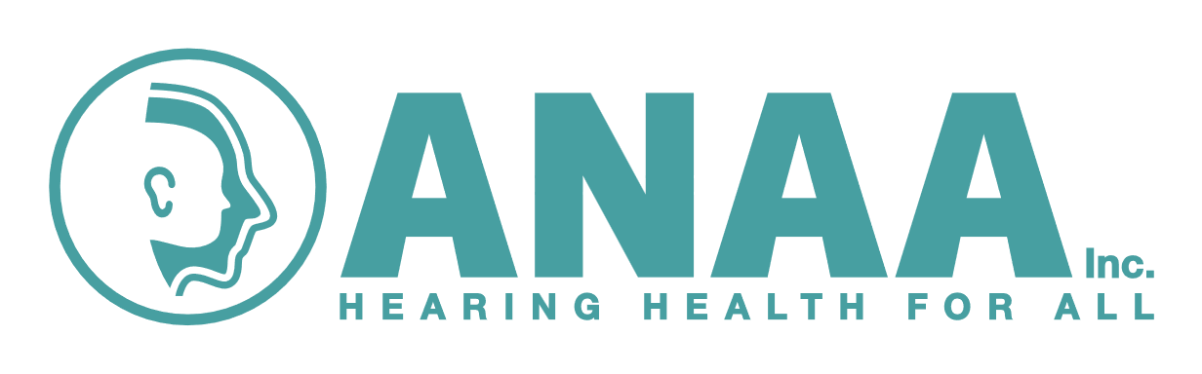

**Application for accreditation as a Clinical Advisor in Audiometry Nursing 2025**

**Applicant**

Name: …………………………………………………………………………………………………...

Address: …………………………………………………………………………………………………...

Phone: (H)…………………………………...(W)………………….……………..….

Mobile: …………………………………………………………………………………………………...

Email: (please print clearly) …………………………………………………………………………………….

I meet the criteria and wish to apply for accreditation with ANAA Inc. as a *Clinical Advisor in Audiometry Nursing*

Signed: …………………………………………………………………………………………………...

**Manager:**

I, (name & position) …………………………………………………………………………………...

Of (Local Health District name) …………………………………………………………………………...

Verify that (applicants name) …………………………………………………………………………...

Meets the criteria and is supported by the service to attend the Clinical Advisor’s workshop for audiometry nurses to be held via **Teams from 1pm to 3pm on Tuesday 30th September**, then **present a case study at the ANAA Inc. conference 17th October** (negotiable).

Signed: ……………………………………………………. Date: …………………………...

**Please send Clinical Advisor application to: -**

[Kate.Norton@health.nsw.gov.au](mailto:Kate.Norton@health.nsw.gov.au)

**By 26th August 2025**