**Conference Accommodation& Transport link.**

**Parramatta Park Royal Hotel- (Conference Venue)**

30 Phillip st , Parramatta. NSW 2150

Ph: 9685 0309

**QUOTE**: **1810AUDIOM for discounted rate.**

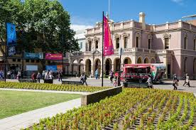

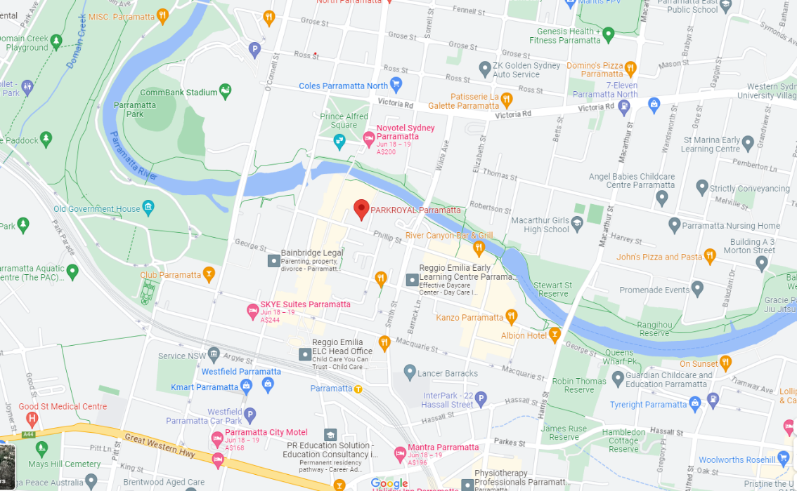

**Website**: [www.atparramatta.com](http://www.atparramatta.com)

This website will direct you to accommodation, restaurants, shopping & attractions in Parramatta.

**Travel**: public transport

<https://transportnsw.info/routes/nsw-trainlink>

Park Royal Hotel Parramatta is an easy 10-15 minute walk from the Parramatta station.

**Parking:**

Eat Street multi-storey parking- Erby Place off Phillip St. Up to 12 hours $35.00 (Opposite Park Royal Hotel- conference venue)

Commbank Stadium- O’Connell St, Parramatta. (short walk to Park Royal Hotel) $10-13 /day.

Wilson parking-140 & 150 George st, Parramatta. Early Bird $16/day or maximum rate $25

Recommend leave the car at home & come by public transport.

**Other accommodation bookings:**

Meriton apartments on Church st- 5 minutes walk to conference.

Meriton apartments on George st- 10 minutes walk to conference.

New accommodation with suites/facilities, great for shared group. Suggest get in early whilst rates are cheaper!

**Booking.com**

**Stayz.com**